User ManualWebhunter 2017

short line

26th March, 2016

# Introduction

Dugway Proving Grounds is responsible for the testing and development of countermeasures for biological and chemical weapons. They have developed a method to study bioaerosols using scanning electron microscopy of aerosols on Tarantula spider webs.

The Web Hunter program is an ImageJ plugin that automates the process of measuring and analyzing the micrographs. Droplet and spindle features of the micrograph are automatically determined and statistics of the results are provided in a html report.

# 

# Installation

## Steps

1. Please insure that Java Runtime Environment (JRE) for Java 1.8 is installed
   1. See <http://www.oracle.com/technetwork/java/javase/downloads/jre8-downloads-2133155.html>
2. Copy the install_webhunter folder from the Installation folder in the Deliverables folder to your computer

## 

# Running the program

1. Use file explorer to open the install_webhunter directory
2. Double click on the webhunter.bat file
3. Change the parameters if needed. See Web Hunter Parameters for more information.

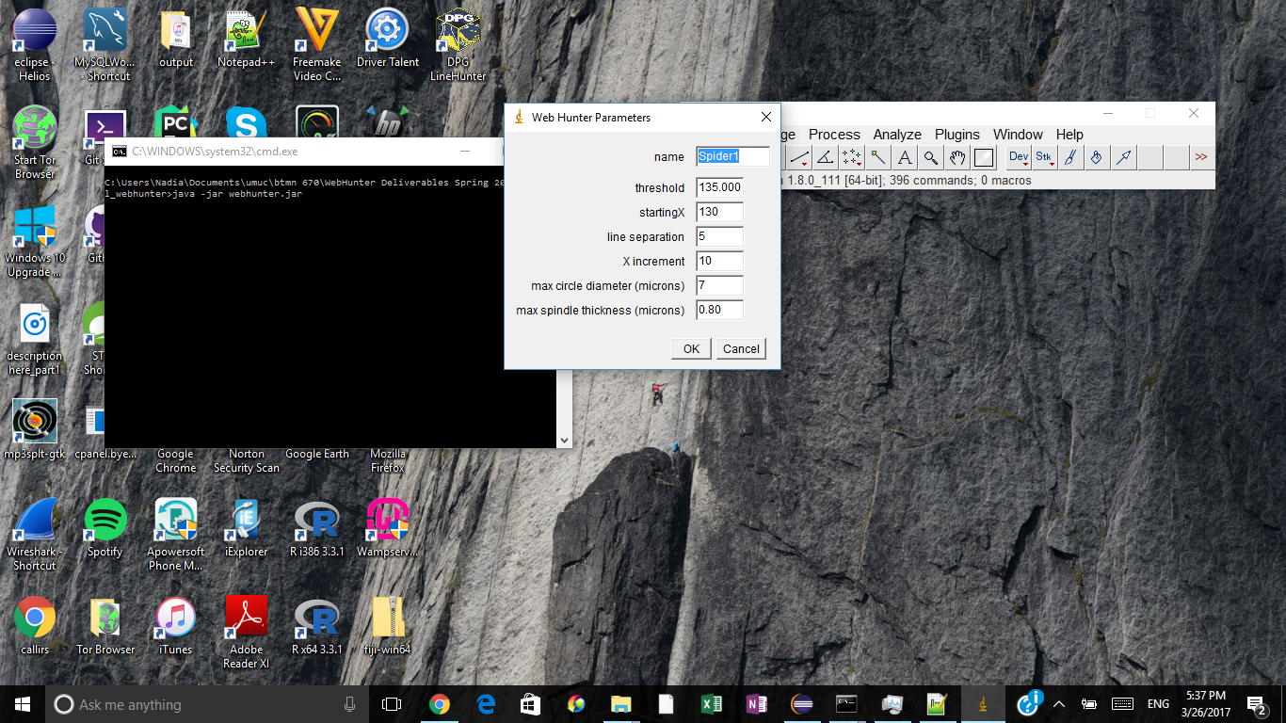

1. Choose the micrograph to analyze (NewSEM506.tif)

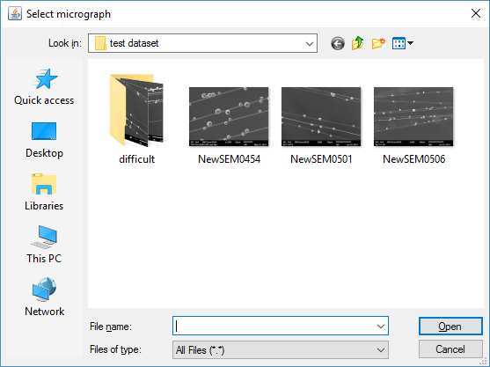

1. Click No for the Asprise prompt. Asprise is the OCR software that reads the micron number on the micrograph annotation

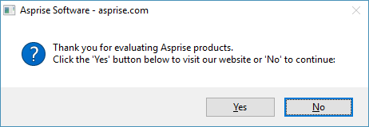

1. The results will be displayed

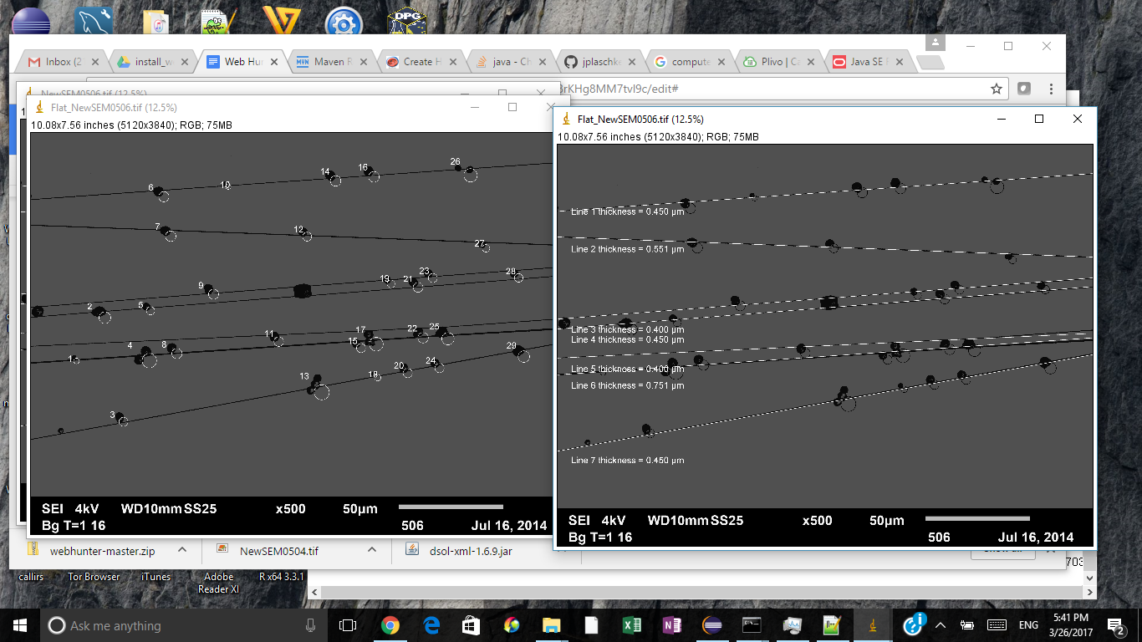

# Reports

A results folder is created that contains statistics for the micrograph. In the results folder, a folder will be created with the name of the micrograph. Within the micrograph folder there will be a list of files that are in html format. The files are prefixed by date and time in the form of YYMMDDHHMMSS.

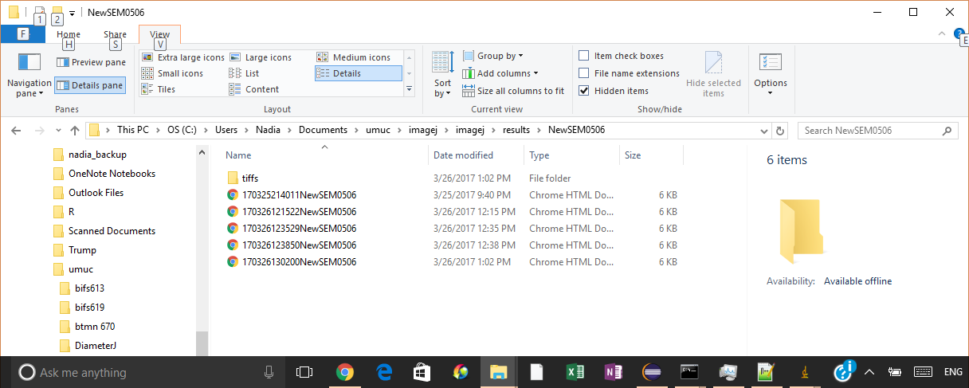

Double click on the html file to see the report. An example is shown below

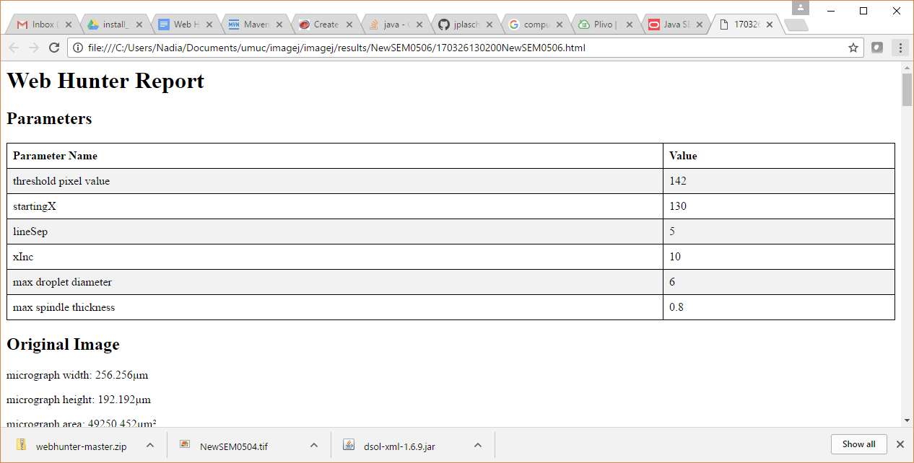

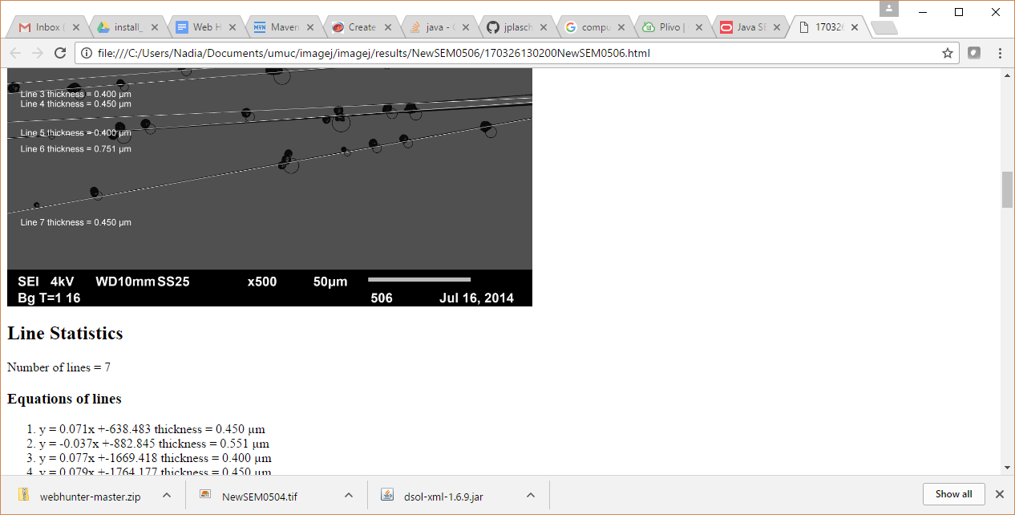

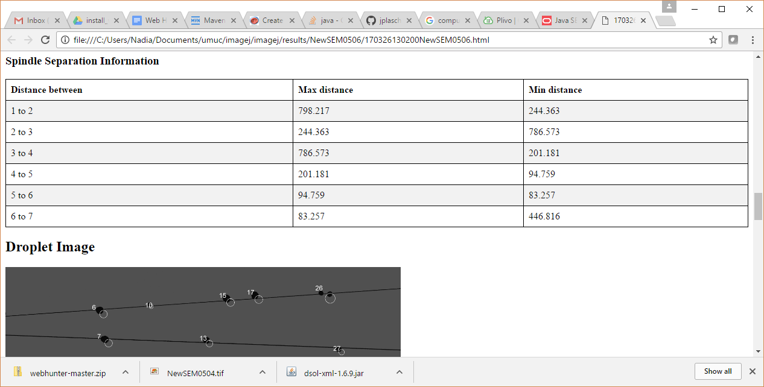

# Web Hunter Parameters

Use the following for SEM506

# 

Use the following for SEM506

**threshold** - used to change the image to background and spindle/droplet (foreground) pixel values. Background is set to 80 when the pixel value is below threshold and foreground is set to 10 when pixel value is above threshold

**startingX -** is the x-axis value where the program will start searching for lines. It should be chosen such that the vertical line at startingX bisects all lines and does not bisect a droplet

line separation - not used

**X increment -** The program increments the x value starting at startingX to look for line edges

**min circle diameter -** minimum diameter of circle to search for

**max circle diameter -** maximum diameter of circle to search for

**max spindle thickness** -maximum spindle thickness to look for

